Session 1- Identify
Site Audit

Please complete before ATA Session 2

Date of assessment:
Date of assessment:

Date of assessment:

As Active Travel Ambassadors (ATAs) you might already know what travel issues affect students at your school. You can find out what travel issues affect students at your school by completing the Site Audit Form.

Completing the Site Audit

Some barriers to active travel might be caused by access issues to your school. Head out with your team to carry out a Site Audit of your school grounds and the streets around your school. It might help to split up into smaller teams to complete the Site Audit. Take note of any barriers that you think would stop people from travelling to school actively.

Site Audit

Cycle Parking: Does your school have cycle parking facilities?
Type of Cycle parking | Tally
Uncovered Sheffield Stands:
(Example)
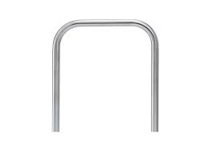

Covered Sheffield Stands:
(Example)
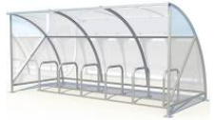

Cycle Pod / Mini Pod:

Other Cycle Spaces (eg. Bike Racks):
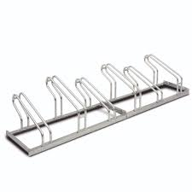

Total Student Cycle Parking Spaces:

Total Visitor Cycle Parking Spaces:

Total Staff Cycle Parking Spaces:

How many bikes are in the bike sheds and how many are secured with locks?

Scooter Parking: Does your school have parking facilities for scooters?
Total Scooter Parking Spaces:

Storage Lockers: Does your school provide pupils with lockers to keep their bags/cycle helmets/workbooks etc in?
Number of Storage Lockers for Equipment:

Showers: Are showers available at your school?
Number of Showers available:

Coach/Bus Parking:
Number of coach/bus parking spaces:

If traveling by school bus, where do pupils get dropped off?

Do pupils getting the bus to school have to cross any roads after being dropped off?

Are coaches/buses allowed on to the school site/into the school carpark? Or do they have to drop off outside the school gates?

Are there any members of school staff on your bus?

How do pupils behave on your school behave?

Motorcycle/Scooter parking facilities
Number Motorcycle/Scooter parking spaces:

Car Parking: what does your school carpark look like?
Type of parking spaces | Tally
Accessible Parking bays

Car share parking bays

Car club parking bays

Electric vehicle parking bays

Electric vehicle charging points

Staff parking bays

Visitor parking bays

Road safety: Have a look at the roads outside your school gates and write down the following.
Name of road (outside main entrance):
Name of other roads surrounding the school:

Speed limit of the road outside the main entrance:

What are the walking routes like to school?

Can you think of any barriers that stop pupils travelling actively to school? The more detail, the better!

Walking access to school:

Cycling access to school:

Bus access to school:

Rail access to school:

Road access to school:

How many of the following crossing facilities are within 500 metres of your school?

Type of crossing |  | Features of crossing | Tally
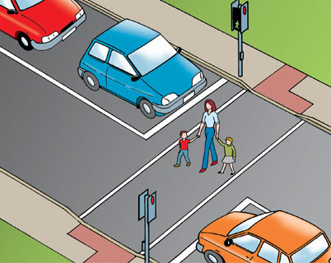 | Pelican Crossing | - Controlled by traffic lights  - Request to cross by pressing button and waiting for a green man  - No black and white marks on the roads
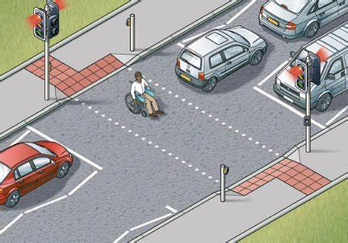 | Puffin Crossing | - Intelligent versions of pelican crossings  - Sensors on top of lights which can sense when a pedestrian has finished crossing  - Green man stays for as long as it takes to cross the road – good for those who may take a little longer to cross.  - Red man shows as soon as person has crossed so traffic can move again.
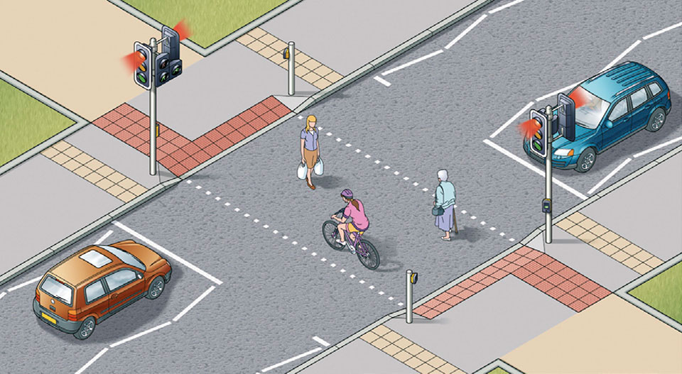 | Toucan Crossing | - Like pelican crossings but make it easier for cyclists to cross too  - Cyclists do not need to get off their bikes to cross (usually they would)  - Green bike will show at the same time as the green man
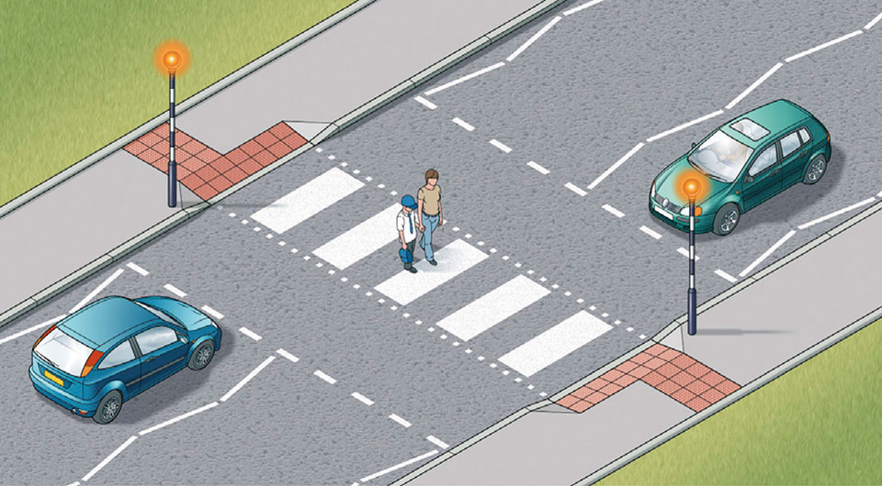 | Zebra Crossing | - Uncontrolled crossings (no traffic lights)  - Black and white stripes on the road.  - 2 flashing yellow beacons  - Zigzag lines on road leading to crossing.
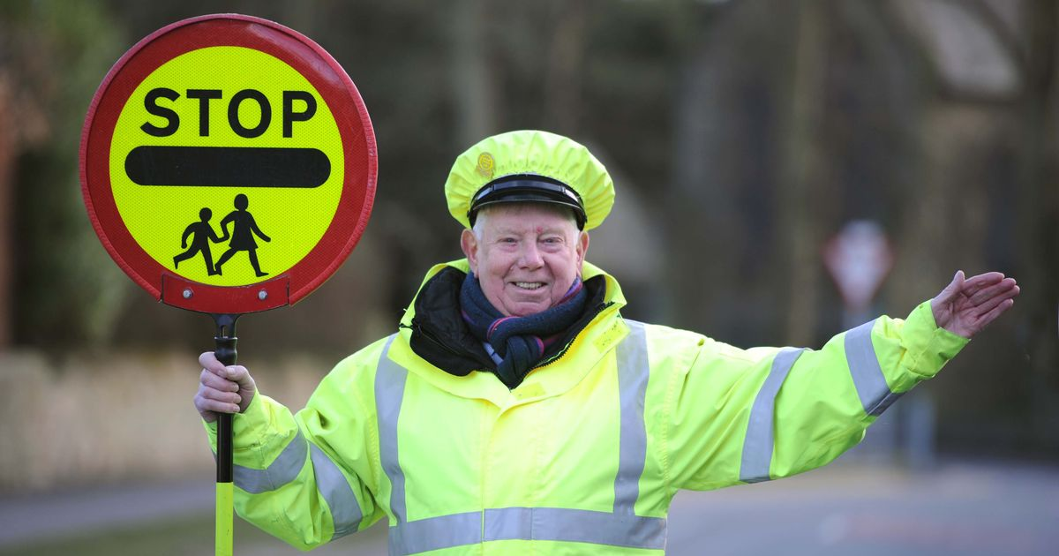 | School Crossing Patrol | - Lollypop person in bright yellow jacket present at crossing to help students cross  - Uncontrolled (no traffic lights)  - Usually near the entrance to a school or on the busiest roads nearby
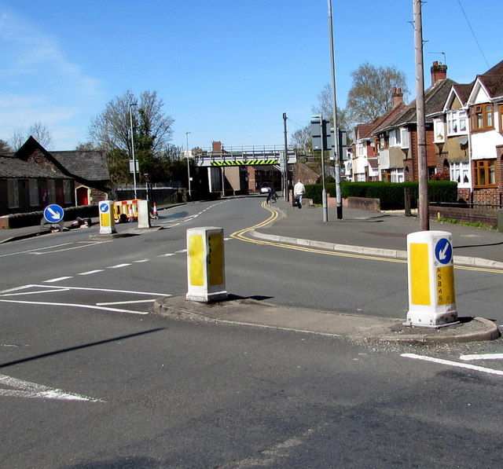 | Pedestrian Refuge | - An island in the middle of a road where pedestrians can wait to cross a busy road  - Helps people cross when the road is busy in both directions  - People can wait in the middle until it is safe

