Poster Report Template

OUR OBJECTIVE
- What did you decide to tackle and why?
- What goal did your project set out to achieve and why?

FUTURE PLANS
- Will any of your project activities continue?
- How could you improve your campaign if you did it again?
- Is there another travel issue that needs your attention?
KEY ACHIEVEMENTS AND EVIDENCE
- How many people travelled more actively/sustainably?
- How many people did you present to?
- How many people participated?

PHOTO HIGHLIGHTS
- Insert photos that showcase your ATA work

QUOTES, MEDIA, PRESS
- Include quotes from teachers and students about a change your campaign has made or is making!
- Include the person’s name and title after their quote

COMPETITION ENTRIES
- Insert pictures of any posters

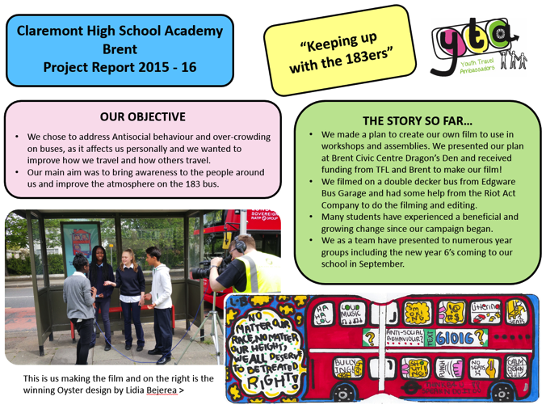
This is an example Project Poster Report from a school in London that took part in the YTA campaign
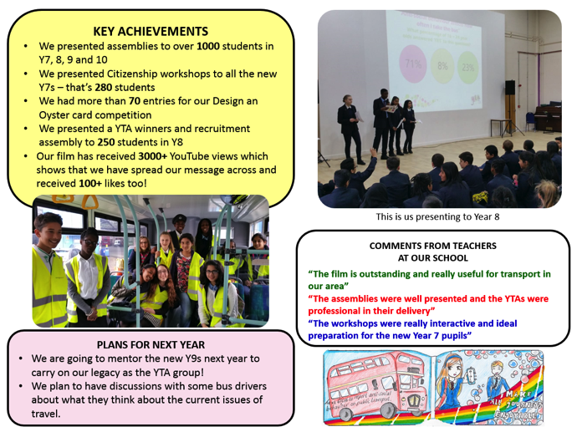
What do you think is good about it? Are there any ideas that you can use for your poster report?
OUR OBJECTIVE
FUTURE PLANS

KEY ACHIEVEMENTS AND EVIDENCE

PHOTO HIGHLIGHTS

QUOTES, MEDIA, PRESS
COMPETITION ENTRIES

